Image Composition
Your initial impulse may be to use the camera’s LCD monitor instead of the viewfinder to compose pictures. You can do this, but this technique can also result in “soft” focus images; holding a lightweight camera away from your body is an invitation for motion blur. Holding the viewfinder to your eye provides built-in stabilization that helps ensure sharp images.
To stabilize the camera, hold it with one hand, and support it with the other. Keep your elbows close at your side. Stand with your feet shoulder-width apart to steady the camera. Get close to your subject when possible. This eliminates potentially distracting background details and focuses attention on your subject. Pay attention to the background!
Use the Rule of Thirds! Avoid placing objects dead centre – this helps to create visual interest. Try to take shots from interesting angles. Force people to see things in unique ways. A decent photo must have decent composition.
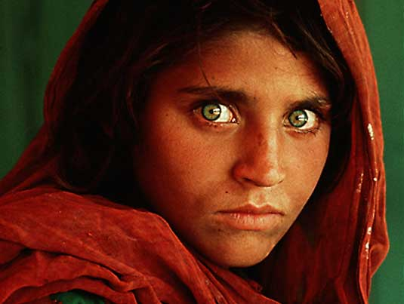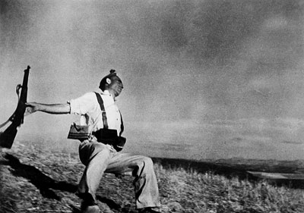
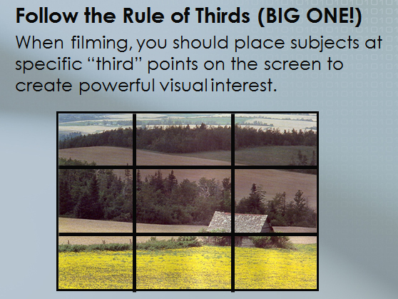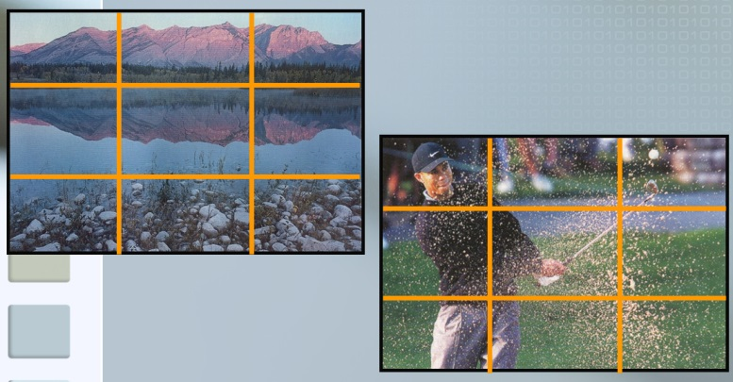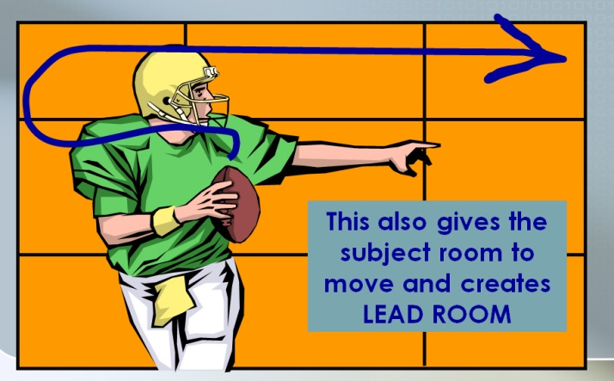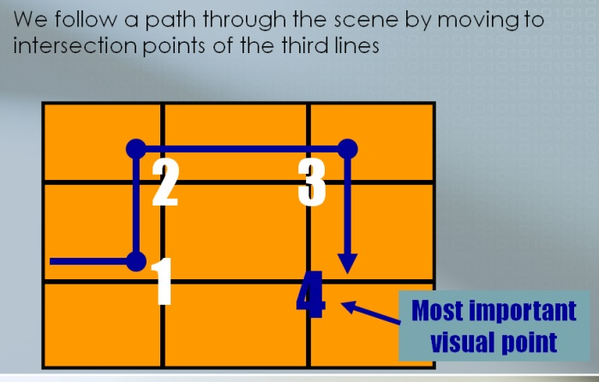

Shutter Speed
A camera’s shutter speed refers to the length of time the shutter stays open, allowing light to enter the camera. The faster the shutter speed, the less light that enters the camera and the quicker the image is captured. A good photographer knows how to make aperture settings and shutter speed work together! As with exposure settings, most digital cameras have auto-shutter modes. Be aware of how different shutter speeds affect an image.
Longer shutter speeds will cause moving subjects to appear blurred. Freezing quick moving subjects require fast shutter speeds.
Shutter speed also needs to be adjusted depending on the type of subject being photographed. Fast moving objects require a fast shutter speed (such as 1/500 of a second) – sports or actions shots
For shutter speeds lower than 1/125, you should use a tripod or the image will likely appear blurry. A camera’s shutter speed refers to the length of time the shutter stays open, allowing light to enter the camera.
The faster the shutter speed, the less light that enters the camera and the quicker the image is captured. You may need to adjust the camera’s ISO setting – ISO setting, or film speed -- on a digital camera may/will effect the amount of “grain or detail” within the photo.
A good photographer knows how to make aperture settings, ISO settings, and shutter speed work together!
Task:
- Select a well lit moving subject.
- Select a slow shutter speed (approx. 1/8 ) and take a picture.
- Adjust the shutter to approx. 1/30 and take a picture.
- Adjust the shutter to approx. 1/500 or faster and take a picture
- Repeat the series with another subject.
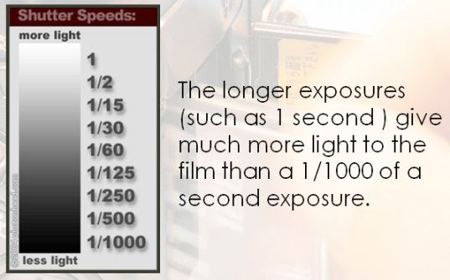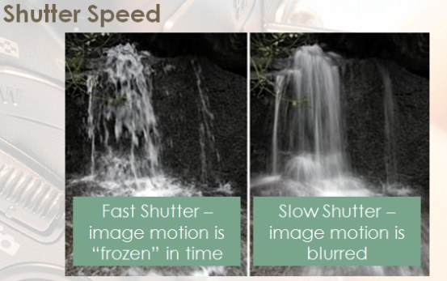
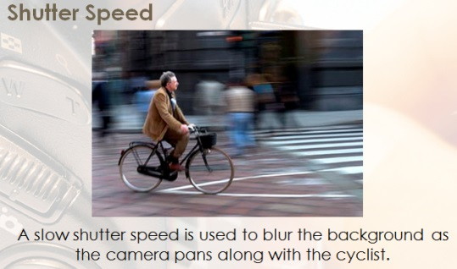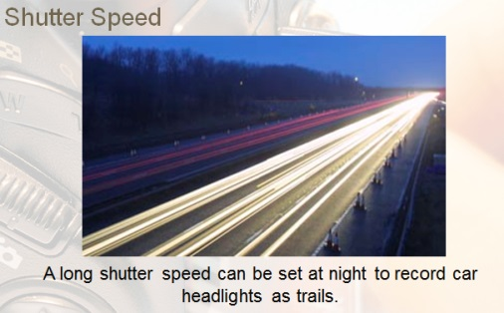
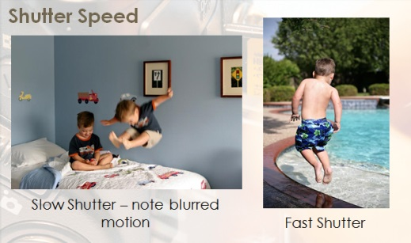
ISO SPEED
ISO refers to the speed at which the camera’s CCD captures the image. Lower ISO speeds (200) create a higher quality image but require longer exposure times. Lower speeds are well suited to brightly lit subjects and still life photos. Higher ISO speeds (1000 or higher) result in quick exposure times with slightly reduced quality. Higher speeds are suited to low light conditions or moving subjects.
Task:
- Select a subject.
- Use the camera controls to adjust the camera to the lowest available ISO speed and take a picture of your subject.
- Readjust the ISO speed to the highest available and take another picture of the subject.
- Select another subject and repeat the process.

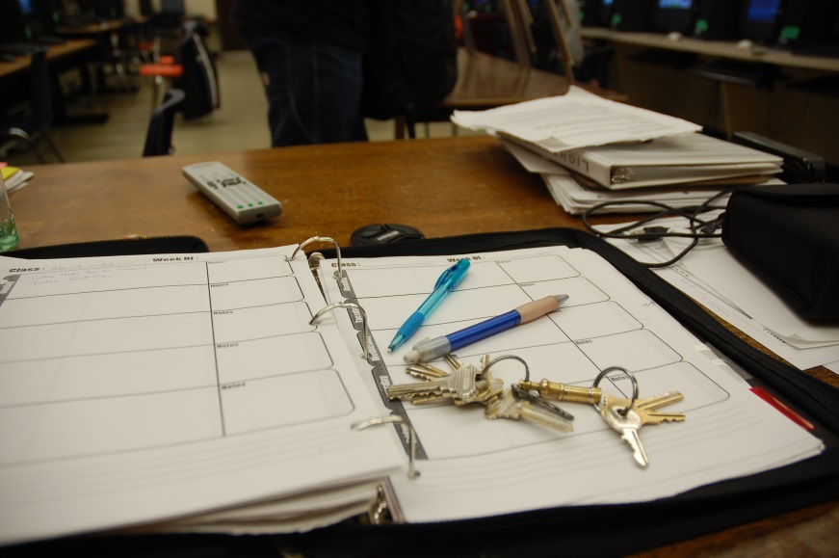
ISO at 200
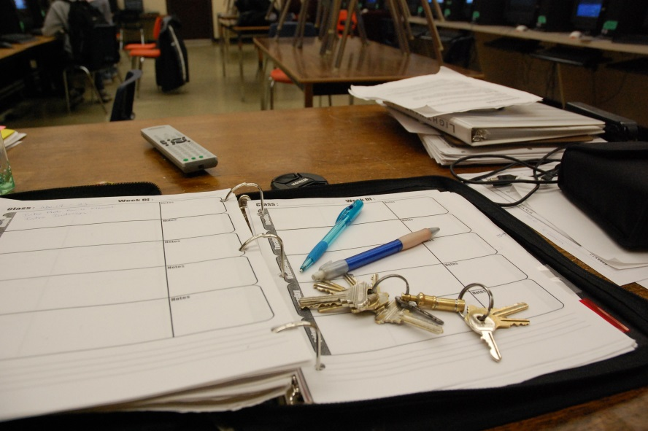
ISO at 1600

Aperture Settings/ Depth of Field
Refers to the size of the hole the lens uses to allow light into the camera. Aperture is measured in F-stops with an F-stop of 3.5 being a large aperture and an F-stop of 22 being a small aperture. Not to be confused by the large F-Stop number and the actual size of the “opening” of the camera’s aperture, i.e., theseF-stop numbers are really just fractions, therefore f 3.5 is 1/3.5 where as a very small f22 is 1/22nd (very small).
Large apertures will allow light into the camera quickly but they create a picture with short depth of field. This means that only a small range of the picture, the subject, will be in focus. Conversely, a small aperture allows less light into the camera causing longer exposure times but the pictures will have large depth of field. This means the foreground, background, and subject will be in focus. Aperture settings will have an effect of/on the visable depth of field.
Task:
- Select a well lit subject with good range of depth and detail along the Z- axis.
- Set the camera’s aperture to the largest available aperture (lowest F-stop) and take a picture.
- Set the camera’s aperture to the smallest available aperture (highest F-stop) and repeat the picture.
- Select another subject and repeat the sequence.
Note:
- Reducing the aperture will mean that less light is allowed into the camera resulting in longer shutter speed times. This means that you must use a tripod to eliminate camera shake. It is a good idea to use the self timer mode on the camera to prevent camera shake caused by pressing the shutter button. As you’ve already learned from your video lessons, a camera’s aperture is the opening that allows light into the lens (think of the iris in your eye).
- Setting the aperture correctly is important for ensuring properly exposed photos (meaning the correct amount of light).
- A large aperture setting lets in more light and is useful in more darkly lit situations.
- A small aperture setting is better suited for brightly lit scenes.
- Most digital cameras feature an auto-exposure setting that automatically adjusts the aperture as lighting conditions change.
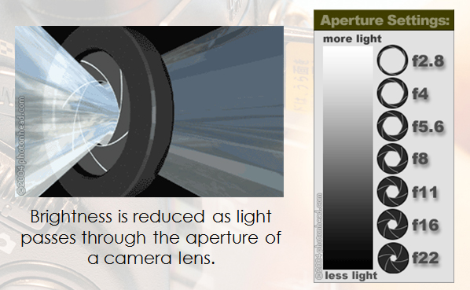
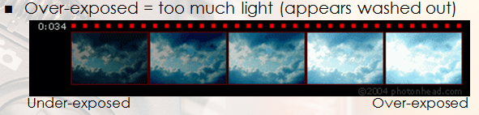
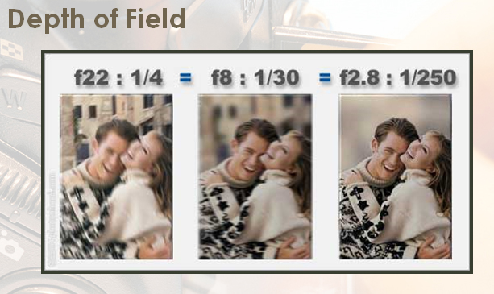
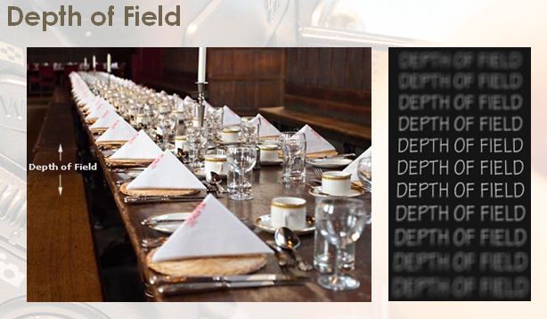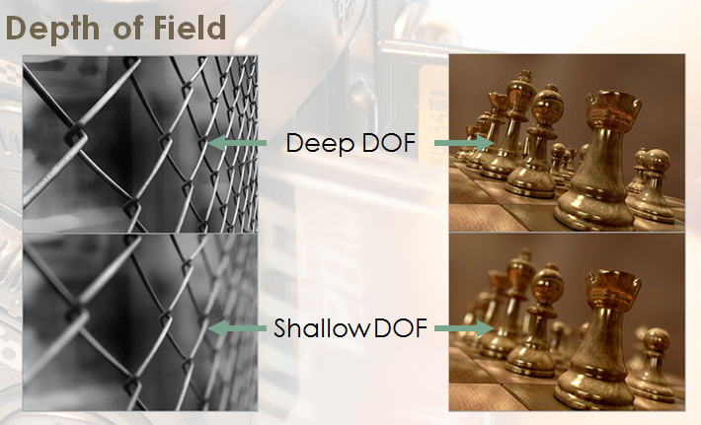

White Balance
White balance is a camera feature that compensates for colour cast in the pictures caused by the colour temperature of the lighting you are working with. Natural, incandescent, and fluorescent lights all have their own colour which will affect how white appears in your photos. The camera has an automatic white balance setting but it also allows you to select different settings based on the lighting that you are using.
With proper white balancing, white objects in your photos appear as white instead of with an orange or blue cast. Some digital cameras have an auto-white balance feature, but be careful as it isn’t always accurate. You can correct white-balance problems on the computer (with programs such as Photoshop).
Task:
- If the weather is nice select an outdoor subject that contains white areas.
- Use the camera’s controls to adjust the white balance to natural light. Take a picture.
- Readjust the white balance to Fluorescent and repeat the picture.
- Readjust the white balance to Incandescent and repeat the picture.
- Select and indoor subject and repeat the process taking three more pictures indoors.

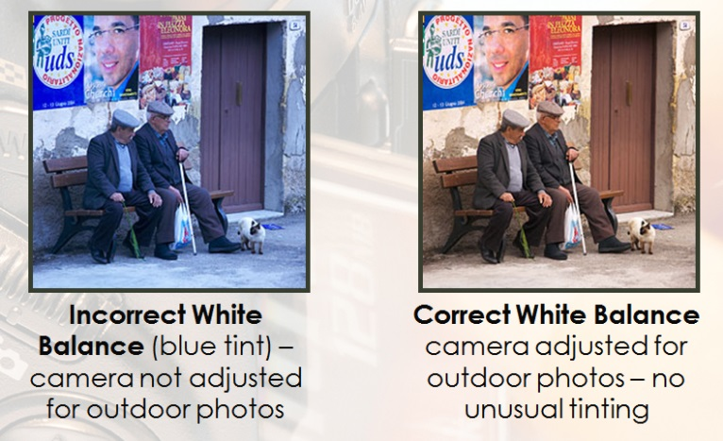
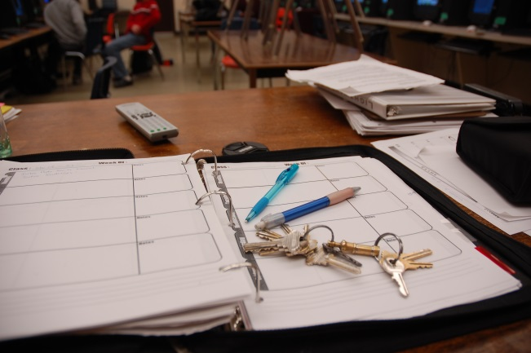 indoor fluorescent setting
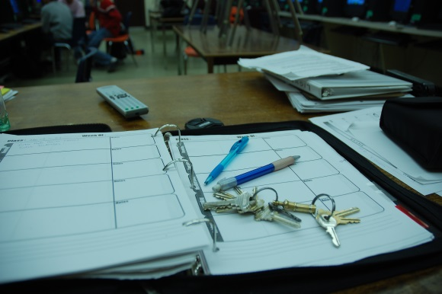 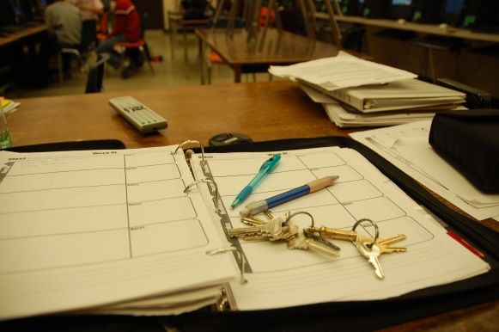
indoor, incandescent setting indoor, sunlight setting
Lighting/Camera Setup
You will need to shut off the flash on the camera as you do not want it to interfere with the light set up. You will also need to adjust the camera’s automatic exposure area. Under normal conditions the camera calculates its exposure settings based on the full frame of the photograph. Since you are using a dark background with a bright subject, this will result in your subject being overexposed (too bright). You will need to change the cameras exposure area to spotlight mode so that it will calculate exposure based only on the subject.
Lighting Setup
You will be using a 3 point lighting kit with a key light, a fill light and a back light.
The key light should be set at roughly a 45 degree angle (both vertically and horizontally) to your subject. With the key light aimed correctly your subject should be brightly lit with heavy shadow patterns caused by the nose and the eyebrows.
The fill light will be used to soften, but not eliminate, the shadows. It should be set at approximately a 45 degree angle on the opposite side from the key light. Aim the fill light away from the subject and use the umbrella reflector to reflect light onto the subject. With both key and fill lights on the subject should be well lit with light shadow patterns caused by the eyebrows and nose.
The background light should not be aimed at the subject. It will be aimed at the backdrop in order to light it evenly and eliminate any shadows caused by the key and fill lights.
Remember:
Use the camera’s review feature to record the exposure settings, ISO, Shutter, Aperture and note the lighting conditions for each of your photos. You may also right-click on the photo in Windows, and view all camera settings in “Properties” (detail dialogue box).
Task:
- With no lights (other than the room light), use a flash to see just how terrible flash photography compares to 3-point lighting photography
- Use a Leave the stage lights on and take a picture of the subject.
- Turn on the key light, shut off the stage lights and take a picture of your subject. Basically, you will initially use “1-point” then “2-point” lighting to get a better idea how portrait lighting effects photography.

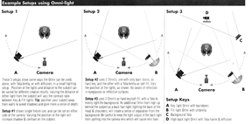
Product Photography OR Nikon Vs. Canon Comparison
Product Photography:
The purpose of this exercise is to allow you to experiment with product photography tent. You will use an infinite horizon(seamless background), Lighting tent and the macro and self timer features on the camera.
Remember :
Use the camera’s review feature to record the exposure settings, ISO, Shutter, Aperture and note the lighting conditions for each of your photos.
Camera Setup
You will need to set the camera to Macro mode (usually indicated by a flower symbol) this will allow the camera to operate very close to a subject. Set the camera on a tripod and set the camera to self timer mode, this will eliminate any camera shake caused by pushing the shutter release.
Task:
- Select a subject.
- Place the subject on a desk and take a photo of it under the room lights.
- Shut the room lights off and light the subject with the supplied spotlights take another photo.
- Set up the lighting tent. Fold the front wall of the tent. Place the background so that there are no creases. Place the subject in the tent.
- Place the light sources so that they shine in equally from the sides slightly ahead of the subject.
- Fold down the front wall of the tent. Place the camera on the tripod so that the lens is inside the tent.
- Compose the picture so that the subject fills the frame.
- Use the camera’s self timer to take a picture of the subject.
- Change the background and repeat.
- Repeat with other subjects.

OR

Nikon Vs. Canon Comparison:
The purpose of this exercise is to allow you to experiment with both the Nikon (D90 or D3000) and the Canon (T5i) dslr cameras. Use both cameras on automatic, taking the exact same photo – with comparable lens, i.e., 18 -130 mm lens. Then “play” with manual settings using the main dial at the top of the camera.
Task:
- Take several photos of the same subject under different conditions, i.e., indoor, outside, etc.
- Compare the “properties” of the photos using MS Windows, i.e., right click and see details.
- Write a paragraph of your opinion of the camera, i.e., ease of use, display, photo quality, camera weight (comfort), which would you prefer, comparable costs (use Henry’s or Best Buy web sites)

